Cover letter

Dear Editor of Oecologia australis,
We state that all of us have approved this manuscript. It hasn’t been submitted nor published in any other journals. We also agree that this paper will be published upon payment of the cost according to the value indicated on the journal’s page.
Here are five independent referees, as solicited:

- Beatriz da Silva Brito (beatrizbritovix@hotmail.com)
- Augusto Vinhas Tozani (atozani14@gmail.com)
- Diego Henrique Santiago (diegosantiagoherpeto@hotmail.com)
- Jéssica Mascarello Graciano (jessicagraciano9@gmail.com)
- Rafael Gonçalves da Silva Quadros (rafaelgsq01@gmail.com)

Kind regards,

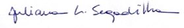
Juliana Segadilha

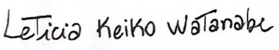
Leticia Keiko Watanabe

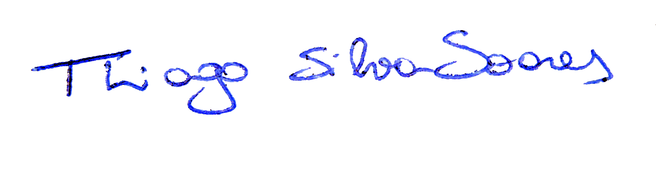
Thiago Silva-Soares

