UNIVERSIDADE FEDERAL DO PARÁ, BRASIL

September 23, 2021
To: Oecologia Australis (OA)
Dear, editor
We are submitting an article entitled “INSETOS AQUÁTICOS BIOINDICADORES DE MUDANÇAS DE USO DA TERRA NO PARÁ, BRASIL: EVIDÊNCIAS E PERSPECTIVAS” for review in OA.
(1) all authors have seen and approved the submitted manuscript;
(2) the manuscript has not been published;
(3) the manuscript has not been submitted simultaneously in other
journal(s);
(4) all authors agree that the article will only be published upon payment
of the cost of the manuscript according to the amount indicated on the
Oecologia australis page; and
(5) provide names along with institutional affiliation and contact details
of 5 (five) independent referees:
Referee 1: Dra. Neusa Hamada, INPA (neusaha@gmail.com); Referee 2: Dr. Luiz Nessimian, UFRJ (jnessimian@gmail.com); Referee 3: Dra Carla Polaz, ICMBIO (carlapolaz@gmail.com); Referee 4: Dr. Danyelton Dantas, ICMBIO (danyhelton@gmail.com); Referee 5: Dra Sheyla Couceiro, UFOPA (sheylacouceiro@yahoo.com.br);
For this reason, we believe this article is a great contribution to OA readers.
All authors declare:
The information has not been published before.

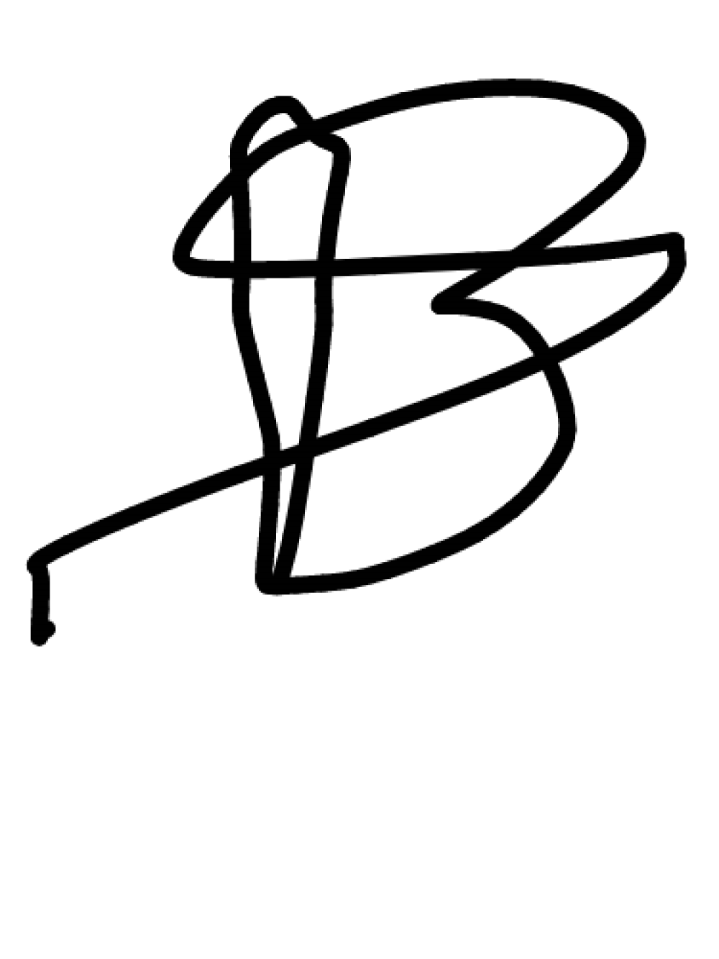  Dr. Leandro Schlemmer Brasil |   Dra. Karina Dias-Silva
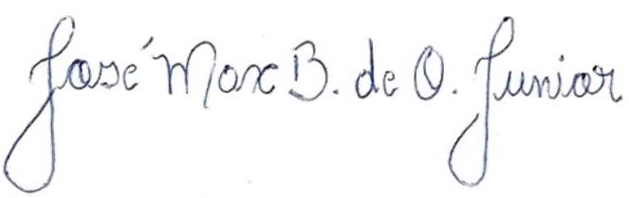  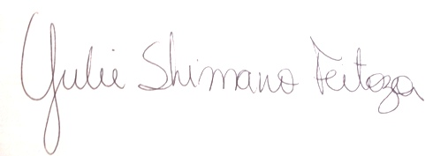  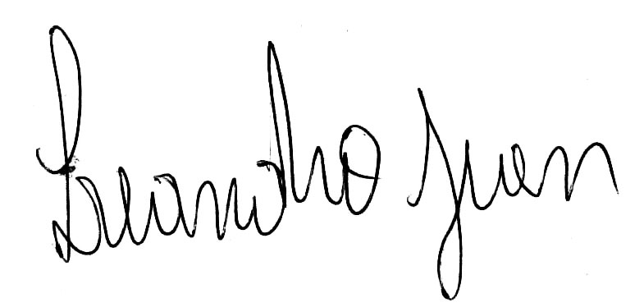  Dr. Jose Max Barbosa de Oliveira-Junior | Dra. Yulie Shimano
Dr. Leandro Juen

