Recife, 13 December 2021
To Dra. Camila dos Santos de Barros
Editor-in-Chief, Oecologia Australis

Dear Editor,
We are delighted to submit our original research entitled: " checklist and habitat distribution by the avifauna of the ecotourism park Cachoeira do urubu: a fragment of the Atlantic forest of the center of endemism of Pernambuco” to Oecologia Australis. We herein certify that this study has not been already published and is not under consideration for publication elsewhere.
Our study consists of a survey of avifauna in a fragment within the Pernambuco Endemism Center (CEP) using bird survey techniques, such as mist nets and listening points. Our results indicate that this CEP fragment, surrounded by a sugarcane matrix is a true oasis for the avifauna, supporting the endemic taxa of the CEP avifauna (Tangara cyanocephala coralina and Picumnus pernambusensis).
The importance of this survey and later the monitoring of avifauna becomes even more relevant for reasons that the fragment, which presents a scenic beauty, is used by tourists as a leisure area.
We believe Oecologia Australis would be the perfect venue to publish what we consider to be an important survey of avifauna in a fragment of the Pernambuco Endemism Center that has been little studied and because of the importance of this fragment in the maintenance of avifauna in this region surrounded by a matrix of sugar cane.
Here, we express that all authors agree with the submission to the journal and approve all content in this study presented, as well as all authors agree that the article will only be published upon payment of the cost of the manuscript according to the amount indicated on the Oecologia australis page, and the manuscript has not been submitted simultaneously in other journals.

Best regards,
Victor Leandro-Silva
Programa de pós-graduação em Etnobiologia e conservação da Natureza. Departamento de Biologia, Universidade Federal Rural de Pernambuco, Recife, PE, Brazil.
Jonathas Lins de Souza
Programa de pós-graduação em Biodiversidade. Departamento de Biologia, Universidade Federal Rural de Pernambuco, Recife, PE, Brazil.
Mauricio Cabral Periquito
Observadores de Aves de Pernambuco, Pernambuco, Brazil.
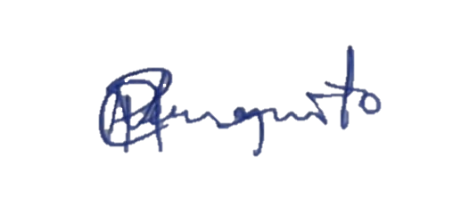
Abraão Ricardo Tenório Gomes
Observadores de Aves de Pernambuco, Pernambuco, Brazil.
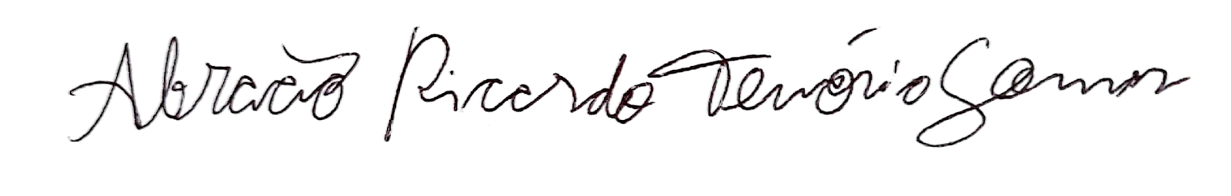

Jozélia Maria de Sousa Correia
Departamento de Biologia, Universidade Federal Rural de Pernambuco, Recife, PE, Brazil.

