Dra. Camila dos Santos de Barros, Editor-in-Chief

Oecologia Australis

February 2022

Dear Dra. Barros:

I am writing to submit our manuscript entitled “DIET COMPOSITION, CONDITION FACTOR AND INTESTINAL COEFFICIENT OF ASTYANAX LINEATUS IN TWO STREAMS UNDER DIFFERENT ANTHROPOGENIC PRESSURES IN CENTRAL BRAZIL” for consideration as a Oecologia Australis Original Article.

Given that the manuscript makes important contributions to stream ecology, we believe that the findings presented in our paper will appeal to the readers who subscribe to Oecologia Australis.

Each of the authors have seen and approved the submitted manuscript, as well as
confirm that this manuscript has not been previously published and is not currently under consideration by any other journal. Additionally, all of the authors have approved the contents of this paper and have agreed to the Oecologia Australis's submission policies, and agree that the article will only be published upon payment of the cost of the manuscript according to the amount indicated on the Oecologia australis page.

Should you select our manuscript for peer review, we would like to suggest the following potential reviewers/referees because they would have the requisite background to evaluate our findings and interpretation objectively.
- Adriana Coletto Morales - adriana.morales@unesp.br or dri_morales@yahoo.com.br
- Anderson Ferreira - andersaof@gmail.com
- Mayara Pereira Neves - mayara-nevesbio@hotmail.com
- Adriana Maria Espinoza Fernando - adriianaespinoza@hotmail.com
- Elaine Antoniassi Luiz Kashiwaqui - elainealk@gmail.com

To the best of our knowledge, none of the above-suggested persons have any conflict of interest, financial or otherwise.

Each named author has substantially contributed to conducting the underlying research and drafting this manuscript. Additionally, to the best of our knowledge, the named authors have no conflict of interest, financial or otherwise.

Sincerely,

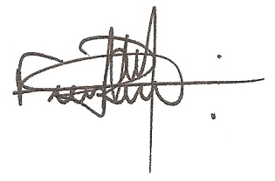
Fernando Rogério Carvalho

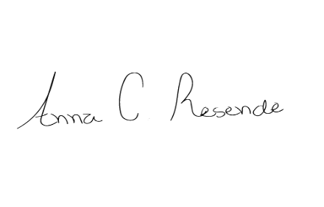

Anna Carolina Resende

Francisco Severo-Neto

