Figures

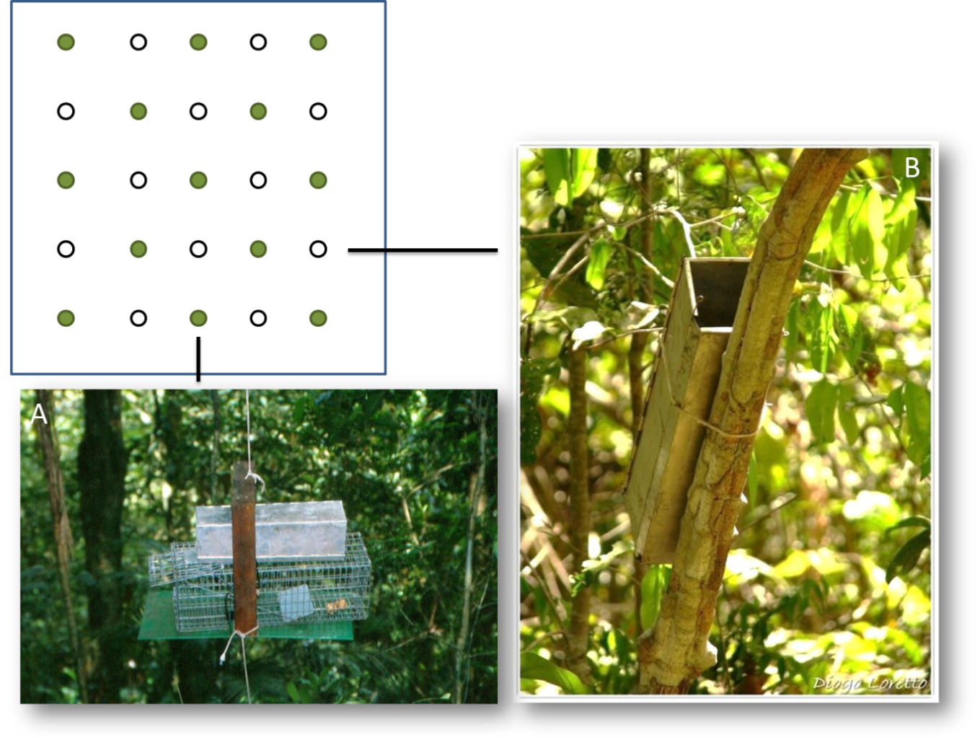
Figure 1. Sampling grid and spatial arrangement of trap stations (upper), where we set Sherman traps (canopy – A; understory - B) and Tomahawk traps (canopy – A) at Garrafão locality, Serra dos Órgãos National Park, Rio de Janeiro, Brazil.

Figure 2. Bait use frequency in ecological studies concerning small mammals in Brazil. Y-axis scale resembles the total number of studies gathered.

Figure 3. Bait use frequency in studies that used sampling effort to capture small arboreal mammals.

Tables
Table I. Small mammal species captured during the field experiment, at Garrafão locality, Serra dos Órgãos National Park, Rio de Janeiro, Brazil. Number of individuals and captures also presented per forest strata under parenthesis. US – understory; Can – canopy.
Species | Individuals (forest strata) | Captures (forest strata) | Capture success
Caluromys philander | 9 (9 Can; 1 US) | 35 (34 Can; 1 US) | 1,22%
Didelphis aurita | 7 (7 Can; 1 US) | 9 (8 Can; 1 US) | 0,31%
Eurioryzomys russatus | 1 (US) | 1 (US) | 0,03%
Guerlinguetus brasiliensis | 3 (US) | 4 (US) | 0,14%
Marmosops incanus | 17 (US) | 35 (US) | 1,22%
Metachirus myosurus | 1 (US) | 3 (US) | 0,10%
Marmosa paraguayana | 8 (8 Can; 7 US) | 38 (18 Can; 20 US) | 1,32%
Philander quica | 5 (3 Can; 3 US) | 9 (6 Can; 3 US) | 0,31%
Rhipidomys itoan | 6 (5 Can; 5 US) | 22 (14 Can; 8 US) | 0,76%
Trinomys dimidiatus | 2 (US) | 2 (US) | 0,07%
Total Geral | 58 (32 Can; 40 US) | 158 (80 Can; 78 US) | 5,49%

Table II. Number of individuals captured (Ind.), total number of captures (Capt.), capture success (CS) and species richness obtained per sampling section during the field experiment, at Garrafão locality, Serra dos Órgãos National Park, Rio de Janeiro, Brazil.
Sampling session | Effort | Ind. | Capt. | CS (%) | Richness
1 | 720 trap-nights | 23 | 36 | 5,0 | 7
2 |  | 24 | 34 | 4,7 | 8
3 |  | 28 | 49 | 6,8 | 9
4 |  | 21 | 39 | 5,4 | 5

Table III. Number of individuals (Ind.) and number of captures (Capt.) per edible bait used during the bait test developed at Garrafão locality, Serra dos Órgãos National Park, Rio de Janeiro, Brazil.
Bait | Understory |  | Canopy |  | Total
 | Ind. | Capt. | Ind. | Capt. | Ind. | Capt.
Pineapple | 13 | 15 | 10 | 13 | 23 | 28
Banana | 25 | 32 | 20 | 41 | 45 | 73
Meat | 3 | 4 | 2 | 3 | 5 | 7
Pasta | 17 | 28 | 14 | 21 | 31 | 49

Table IV. Small mammals captured during the bait test, at Garrafão locality, Serra dos Órgãos National Park, Rio de Janeiro, Brazil. Ind. - number of individuals captured; Capt. - number of captures; Bait – most successful bait attracting the given species; CS – capture success of the best bait; In parenthesis, CS for all bait test; PI – preference index (ratio between the CS of the best bait by the CS of the species).
Species* | Locomotor habits | Ind. | Capt. | Bait | CS | PI
Caluromys philander | Arboreal | 9 | 35 | Banana | 3.61% (1.21%) | 2.98
Guerlinguetus brasiliensis | Arboreal | 4 | 4 | Banana | 0.41% (0.13%) | 3.15
Marmosa paraguayana | Arboreal | 8 | 38 | Banana | 2.91% (1.31%) | 2.22
Rhipidomys itoan | Arboreal | 6 | 22 | Pineapple | 1.11% (0.76%) | 1.46
Didelphis aurita | Scansorial | 7 | 7 | Banana | 0.41% (0.24%) | 1.70
Marmosops incanus | Scansorial | 17 | 36 | Banana | 1.80% (1.25%) | 1.44
Philander quica | Scansorial | 5 | 9 | Pineapple, meat, pasta | 0.28% (0.31%) | **
* We did not consider terrestrial species. ** Philander quica did not have preference index, since 3 of the 4 baits tested were equally successful in capturing it.

