ECOLOGY AND BEHAVIOR patterns OF BLACK howler monkeys Alouatta caraya (HUMBOLDt, 1812, Primates, Atelidae) in ecotone Cerrado-PANTANAL IN THE LEFT BANK OF Aquidauana River, Mato Grosso do Sul, Brazil

José Rímoli^{1, 2,3*}, Rodrigo dos Santos Nantes¹& Antônio Édson Lázaro Júnior¹
¹ Universidade Federal de Mato Grosso do Sul (UFMS), Licenciatura em Ciências Biológicas, Campus de Aquidauana, Aquidauana, Mato Grosso do Sul, MS, Brasil, Caixa Postal: 135, Av. Oscar Trindade de Barros 740, CEP: 79.200-000 - Bairro da Serraria.
² Programa de Pós-Graduação, Mestrado em Biologia Animal, Universidade Federal de Mato Grosso do Sul (UFMS), Campus de Campo Grande, Campo Grande, Mato Grosso do Sul, MS, Brasil. Caixa Postal: 549, Av. Costa e Silva s/n, CEP: 79070-900.
³ Geopark Bodoquena-Pantanal, FUNDECT, Fundação de Apoio ao Desenvolvimento do Ensino, Ciência e Tecnologia do Estado de Mato Grosso do Sul, Rua São Paulo, 1436, CEP 79.010-050.
E-mails: jsrimoli@terra.com.br, rodrigolinguadeboi@hotmail.com, to_saulo@yahoo.com.br

ABSTRACT

The behavior and ecology of a group of black-howler (Alouatta caraya) were monitored on the left bank of the river Aquidauana over 11 months, from september 2008 to july 2009. The group was composed of nine individuals, two adult males, three females and four immature among subadults and infants. Quantitative data were collected in scans of 5 minutes with an interval of 15 minutes. The general activities budget (n = 6434 records) was 64.71% rest, 18.54% travel, 10.13% feed, 3.20% for social behavior and 3.42% for miscellaneous behaviors. The level of rest was similar to patterns of genus (64.71%). The diet (n = 556 records) was composed mainly of leaves (72.83%) and flowers (14.85%) and supplemented by fruits (8.20%) and shoots (4.02%). The consumption of reproductive parts of plants, especially flowers, was relatively high by the standards of southerly populations of the species. Members of the group rested significantly less than that feed during the rainy season. The diet was marked by the consumption of leaves throughout the study. The consumption was higher in the dry at flowers (17.84%) and fruits in the rainy season (12.99%). It also registered a considerable difference in the behavior of adults and immatures, where the first significantly more rested, but spent less time in other categories: food, travel and social interactions. Faced with this situation, it seems likely that the budget was under the influence of group composition, where the predominant immature members, an atypical pattern in the genus. Although this is a work still preliminary, the results indicate patterns of behavior and diet typical of the genus Alouatta, but marginal for the species. The contrasts can be related mainly to the geographic location of the ecotone Cerrado-Pantanal, setentrional area of study, and concomitant ecological differences. There is a clear need to continue the studies of A. caraya in the Bororo region, not only for a more systematic assessment of their ecological patterns, but also contribute to the development of conservation strategies.

Key-words: Alouatta; black howler monkeys; animal biology; behavioural ecology; Cerrado & Pantanal

RESUMO

ECologia e padrões comportamentais de bugios-pretos (Alouatta caraya, HUMBOLDt, 1812, Primates, Atelidae) no ecótono cerrado-pantanal na margem esquerda do rio Aquidauana, Mato Grosso do Sul, Brasil
O comportamento e a ecologia de um grupo de bugios-pretos (Alouatta caraya) foram monitorados na margem esquerda do rio Aquidauana ao longo de 11 meses, de setembro de 2008 a julho de 2009. O grupo era composto nove indivíduos, dois machos adultos, três fêmeas adultas e quatro imaturos entre subadultos, jovens e filhotes. Dados quantitativos foram coletados em varreduras de 5 minutos, com intervalo de 15 minutos. O orçamento geral de atividades (n = 6434 registros) foi de 64.71% para o descanso, 18.54% para o deslocamento, 10.13% para alimentação, 3.20% para o comportamento social e 3.42 para comportamentos não mutuamente exclusivos. O nível de descanso foi similar aos padrões do gênero (64.71%). A dieta (n = 556 registros) foi composta, principalmente por folhas (72.83%) e flores (14.85%) e completada por frutos (8.20%) e brotos (4.02%). O consumo de partes reprodutivas de plantas, principalmente flores, foi relativamente alto para os padrões das populações mais meridionais da espécie. Os membros do grupo descansaram significativamente mais e se alimentaram menos na estação chuvosa. A dieta foi marcada pelo consumo de folhas ao longo do estudo. A ingestão de flores foi maior na seca (17.84%) e a de frutos na estação chuvosa (12.99%). Foi registrada, também, uma diferença considerável no padrão comportamental de adultos e imaturos onde os primeiros descansaram significativamente mais, mas gastaram menos tempo nas demais categorias: alimentação, deslocamento e interações sociais. Frente a esta situação, parece provável que o orçamento geral sofreu a influência da composição do grupo, onde predominaram os membros imaturos, um padrão atípico no gênero. Apesar de constituir um trabalho ainda preliminar, os resultados indicam padrões de comportamento e dieta típicos do gênero Alouatta, embora marginais para a espécie. Os contrastes podem estar relacionados principalmente em relação à localização geográfica mais setentrional da área de estudo em áreas de ecótonos Cerrado-Pantanal e diferenças ecológicas concomitantes. É clara a necessidade de dar continuidade aos estudos de A. caraya na região Bororo, não somente para uma avaliação mais sistemática de seus padrões ecológicos, como também contribuir para o desenvolvimento de estratégias de conservação.

PALAVRAS-CHAVE: Alouatta; bugios-pretos; biologia animal; ecologia comportamental; Cerrado & Pantanal

INTRODUCTION

Patterns of daily activities or activity budget are indirect measures that seek to analyze how primates are and optimize their energy requirements (Altmann 1980, Strier 1987). Energy demands vary not only between species but also intra groups due to differences in the size of the gastro-intestinal tracts, group size and the different energy demands between themselves members of the group, reflections of the different states sex-age, the different reproductive states of females and sexual dimorphism (Clutton-Brock & Harvey 1977, Strier 1987).
The genus Alouatta is composed of nine species with twenty-one subspecies. The species are: Alouatta caraya, Alouatta sara, Alouatta nigerrima, Alouatta belzebul, Alouatta palliata, Alouatta coibensis, Alouatta fusca, Alouatta seniculus and Alouatta pigra (Rylands et al. 1997). In Brazil, we found four species: A. seniculus in the Amazon (Neville et al. 1988), A. belzebul in the northeast Atlantic Forest and the Amazon (Pina 1999), A. guariba in the Atlantic Forest from Bahia to Rio Grande do Sul (Mendes 1985), and finally Alouatta caraya in the Cerrado and Pantanal regions (Santini 1985, Odalia-Rímoli et al. 2008) and the southern limits of their distribution (Bicca-Marques 1991, Miranda & Passos 2005, Miranda 2009, Aguiar 2010).
The howler monkeys (Alouatta spp.) are among the largest platyrrhines (Bonvicino et al. 2001) and have, together with Cebus, the widest geographical distribution (Neville et al. 1988). The black howler monkey, A. caraya (Humboldt 1812) is found mainly in Brazil, in the Cerrado and Pantanal (Santini 1985, Hirsch et al. 2002) and in adjacent areas of Bolivia, Paraguay and Argentina. One of the most outstanding features of the species is their sexual dichromatism, in which adult males are completely black and females and juveniles are yellowish in color.
The behavior of howler monkeys is relatively well understood (Crockett & Eisenberg 1987, Zunino et al. 1996, Bicca-Marques 2003, Di Fiore & Campbell 2007). The social organization and behavior of the genus Alouatta can be characterized mainly by polygyny, low activity rates and high levels of folivory in most populations. A. caraya follows this general pattern, although some ecological data available for the species, most of which were obtained from studies in the extreme south of the species geographical distribution (Santini 1985, Rumiz et al. 1986, Rumiz 1990, Bicca-Marques 1991; Agoramoorthy & Lohmann 1999, Sallenave & Bravo 2003). Until the present study, only two (Nantes & Rímoli 2008, Odalia-Rímoli et al. 2008) was available and provided ecological data of the contact zone of the Cerrado and Pantanal biomes, the region known as Bororo (Coimbra-Filho 1982).
For purposes of the contribution to the knowledge of the species the main objective was to study the behavior and ecology of A. caraya in wet landscape at ecotone Cerrado-Pantanal. Although A. caraya is not in any immediate danger of extinction, the populations are declining throughout most of their range due to the continuous expansion of farming and the fragmentation of natural habitats. In addition to evaluating the ecological and behavioral patterns of the species in the Bororo region on the left bank of the River Aquidauana, Mato Grosso do Sul (MS, Brazil), this study also aimed to provide a database for planning conservation initiatives and management for the species and their habitats in this region.

METHODS

Study Area

The survey was conducted in an urban fragment of Cerrado-Pantanal located on the left bank of the river in Aquidauana, Anastacio city, Mato Grosso do Sul (MS, Brazil), 20 º 29 ’01 ’’S, 55 º 47 ’88 ’’W, in the period between the months of september 2008 to july 2009. The area is located next to Unit I of the Federal University of Mato Grosso do Sul (UFMS), in the downtown area. Its space was established a stronghold of vegetation subject to flooding (months from january to march), reflecting variations in the water regime of the Rio Aquidauana. Its vegetation, characteristic of the Cerrado-Pantanal ecotone, is formed by riparian forest distributed over an area exceeding 40 hectares. For monitoring and observation of the study group, there was the need of opening and maintaining a trail system.

Study Group

During the months of july and august 2008 the river Aquidauana was explored intensively looking for groups of monkeys, after this period, one group was found and followed the left bank of the river Aquidauana. The selected group had a high degree of habituation, due to the animals to live in an area of intense human activity. Most of the area includes residential and business. The area allowed for the traffic of both people (traffic this very often and not only restricted but also the way to the track) as vehicles and vessels that arrived at the river, there to be reformed. Therefore, the choice of the area and the study group was directly related to the possibility of studying the behavior and ecology of a group of primates in an area of strong anthropogenic pressure.
At the beginning of the study in september 2008, the group consisted of eight animals. At that time the composition of the study group consisted of two adult males, two adult females, one female and three subadults of different ages. In 2009, there was a change of grade age and sex of some individuals and, with the birth of an infant, until the month of april the group had nine members of the emigration occurred when an adult male, the group now has eight members. Table 1, present the age and sex composition of the group studied.

Table 1. Composition of the black howlers monkeys group (Alouatta caraya) on the left bank of the River Aquidauana throughout the study period (2008/2009). Include immature infants (<1 year), juveniles 1 and 2 (J1 = 1-2 years, J2 = 2-3 years) and subadults (3-4 years) and adults (> 4 years).
Classes | 2008 | 2009
Adult Males | 2 | 2*
Adult Females | 3 | 3
Subadults Males | 0 | 0
Subadult Females | 1 | 1
Juveniles Males | 0 | 0
Juveniles Females | 0 | 1
Infants Males | 1 | 2
Infants Females | 1 | 0
Total | 8 | 9
*Note: In April 2009, occurred the emigration of an adult male.

ACTIVITIES BUGETS

The pattern of activity was investigated for eleven consecutive months of field, from september 2008 to july 2009. During this period the animals were observed in 11 monthly samples, 1723 scans of 5 minutes that comprised 6434 records with the behavioral and ecological group-black howler monkeys. The data presented here correspond to the months from september-december 2008 and january-july 2009.

Data collection

The collection of data on the basic patterns of daily activities of members of the group of black howler monkeys was based on scanning method also known as instantaneous scan-sampling (Altmann 1974, Martin & Bateson 1993). The method is suitable for the collection of reliable quantitative data on the social behavior of arboreal primates, which have a number of issues of visibility and observational bias (Ferrari & Rylands 1994). We used a sampling scheme for 5 minutes with an interval of 15 minutes. To establish this methodology took into account, using the same scheme with other studies with A. caraya (Santini 1985, Bicca-Marques 1991, Odalia-Rímoli et al. 2008, Nantes & Rímoli 2008).
Scans were performed continuously throughout the period of daily activity in the study group, from dawn to dusk during the sample period of five consecutive days per month. Each scan was recorded: (a) the time and location of the group relative to the tracks, for each member of the group visible during scanning were recorded: (b) your identity, (c) behavior (second pre-defined ethogram), (d) your posture (sitting, lying down, grabbed, suspended by the tail and limbs), (e) group members, neighbors observed the animal within a 10m radius of the subject, (f) distance (s) between observed and the animal (s) other (s) member (s) of the group (g) its height above the ground according to the categories (soil, <5m, 5-10m; 11-20m; > 20m), (h) animal-observer distance, (i) other information deemed relevant.
The behavioral categories that were used in this study were based at first on those used in other studies with Alouatta spp. (Glander 1980, Milton 1980, Mendes 1985, Bicca-Marques 1991) and recently in new studies that generated new information for A. caraya in Mato Grosso do Sul, in the municipalities of Terenos (MS) in Atlantic Forest for Maracaju Sierra (Odalia-Rímoli et al. 2008) and Aquidauana (MS) in wet landscape of ecotone Cerrado-Pantanal (Nantes & Rímoli 2008). The behavioral categories were considered: feeding, when the animal was observed manipulating, biting, chewing and ingesting any food within a list of items such as new leaves, mature leaves, fruits and seeds, buds and flowers; rest: when the animal was still observed (inactive), and when lying down or sitting asleep; travel: when the animal were observed moving over great distances or even short paths in the same tree or between trees and socialization: when the animal was observed engaged in social interactions with other individuals.
Within the context surrounding the general pattern of activities of the study group, one objective was to detect possible differences in the frequency of behavioral categories. Climatic seasons presented in different periods, the rainy and dry seasons. The dry season was characterized by less rainfall and lower temperatures and the rainy season is the opposite table. Thus, for this analysis, data were grouped by season climate: rainy season (october 2008 to march 2009) and dry season (april to july 2009). The differences between the climatic seasons were analyzed using the binomial z test (see Pina 1999). Whereas the significance level of α=0.05, results in order to avoid false positives (Martin & Bateson 1993). The behaviors were calculated for the group as a whole and separately for the group members, adults and immature, to evaluate possible differences in the pattern of behavior related to the subject's age. Diet composition was calculated similarly, dividing the number of records of each item by the total number of feeding records collected during the study period.

RESULTS

The general activity budget for behaviors of the study group (Table 2) was typical of the genus with a predominance of rest periods and low levels of social interaction. The budget is, however, very different in terms of time spent in motion (18.54%), the value is almost half of that obtained for A. caraya (29.9%) living in gallery forests in Terenos (MS) (Odalia-Rímoli et al. 2008), the highest value recorded for a species of the genus (Di Fiore & Campbell 2007), and inferior to the other group A. caraya (25.4%) studied in central part of Aquidauana (MS) town between 2007 and 2008 (Nantes & Rímoli 2008). In A. caraya, Zunino (1986) showed a value of only 2.4% while that of Bicca-Marques (1991) was 17.1%. In most cases, the howlers spend less than 10% of their time to traveling, and rarely more than 20%, although Williams-Guillén (2003) reported a value too high (27.4%) for Alouatta spp.

Table 2. Activities budgets observed for some species of the genus Alouatta spp.

Behavior (% of records)
Species | Rest |  | Feed | Travel | Source
A. caraya | 64.7 | 10.1 |  | 18.5 | This study
 | 48.3 | 24.1 |  | 25.4 | Nantes & Rímoli (2008)
 | 50.9 | 14.7 |  | 29.9 | Odalia-Rímoli et al. (2008)
 | 77.4 | 15.2 |  | 2.4 | Zunino (1986)
 | 63.0 | 14.9 |  | 17.1 | Bicca-Marques (1991)
 | 57.0 | 19.0 |  | 16.0 | Bravo & Sallenave (2003)
A. belzebul | 58.7 | 13.7 |  | 23.1 | Pina (1999)
 | 58.7 | 20.0 |  | 14.2 | Pinto (2002)
 | 55.9 | 7.5 |  | 19.3 | Bonvicino (1989)
A. guariba | 71.8 | 17.3 |  | 11.0 | Mendes (1985)
 | 67.0 | 10.0 |  | 12.0 | Martins (1997)
 | 57.6 | 19.0 |  | 18.8 | Marques (1996)
 | 63.7 | 18.7 |  | 13.2 | Chiarello (1993)
A. palliata | 65.5 | 16.2 |  | 13.4 | Milton (1980)
 | 79.7 | 17.3 |  | 2.2 | Estrada et al. (1999)
 | 57,0 | 13.6 |  | 27.4 | Williams-Guillén (2003)
A. pigra | 61.9 | 24.4 |  | 9.8 | Silver et al. (1998)
A. seniculus | 78.5 | 12.7 |  | 6.2 | Gaulin & Gaulin (1982)
 | 76.3 | 6.0 |  | 16.0 | Queiroz (1995)

Figure 1 shows the behavior of the study group by comparing the seasons. The general pattern of behavior in terms of different categories was recorded in two seasons, dry season (april-september2009) and rainy or wet season (october2008 to march2009).

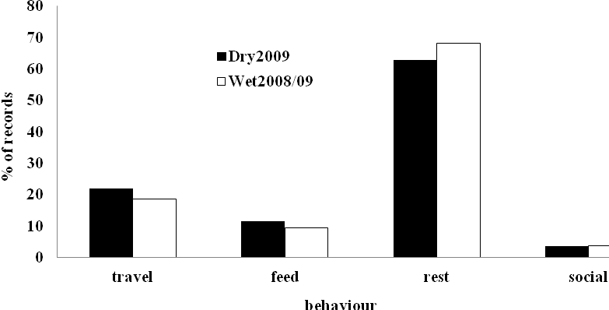
Figure 1. Comparison of behavioral patterns in dry2009 and wet seasons 2008/2009 at the Alouatta caraya study group (n = 1885, dry season, n= 3549, wet season) in the left bank of Aquidauana river.

The analysis in Table 3 presented the results of principal activities correlated with climatic seasons. While the indices obtained for social behavior (z = 0.04, p> 0.5, n = 201) were stable, the members of the group spent significantly more time resting in the rainy season (z = - 2.29, p <0.05, n = 3605), and both, the feeding behavior (z = 2.23, p <0.05, n = 556) and the travelling over de home range (z = 2.57, p <0.05, n = 1072) were higher during the dry season.

Table 3. The activities budget of the group of black-howler (Alouatta caraya) by climatic station, according to the records of instantaneous scan sampling. Records (% of total) in dry season, wet season.
Category | Dry Season |  | Wet Season | z (p)
Feed | 218 (11.56) |  | 338 (9.52) | z= 2.23 (p<0.05)
Travel | 412 (21.86) |  | 660 (18.59) | z= 2.57 (p<0.05)
Rest | 1185 (62.86) |  | 2420 (68.18) | z= -2.29 (p<0.05)
Social | 70 (3.20) |  | 131 (3.71) | z= 0.04 (p>0.05)
Total | 1885 (100.00) |  | 3549 (100.00)

The diet was dominated by plant material, especially leaves (Figure 2), a pattern typical of the genus Alouatta spp. (Di Fiore & Campbell 2007). The use of leaves had a relatively similar diet in comparison with most other related studies with howlers monkeys (Table 4), including A. caraya (Bicca-Marques 1991, Sallenave & Bravo 2003). In contrast, both the fruits and flowers were relatively large, while the consumption of fruits has been lower than the values reported in other studies A. caraya, but similar to sympatric group that live together in Aquidauana between 2007 and 2008 (Nantes & Rímoli 2008). Flowers were appreciated resources in the dry season (april-july 2009) and its consumption was higher (see Table 4) than other groups of A. caraya (Zunino 1986, Bicca-Marques 1991, Sallenave & Bravo 2003).

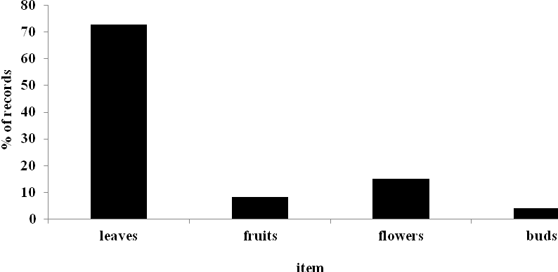
Figure 2. Standard diet overall feeding resources of Alouatta caraya (n = 556).

Table 4. Percentual that principal feed items in the diet from Alouatta caraya (% of feeding records) and other howler species.
Species | Leaves | Fruits |  |  | Flowers |  |  | Source
A. caraya | 72.8 | 8.2 |  | 14.9 |  |  | this study
 | 78.3 | 6.8 |  | 14.8 |  |  | Nantes & Rímoli (2008)
 | 47.5 | 35.5 |  | 12.9 |  |  | Odalia-Rímoli et al. (2008)
 | 74.2 | 23.6 |  | 2.2 |  |  | Zunino (1986)
 | 60.9 | 28.9 |  | 2,7 |  |  | Bicca-Marques (1991)
 | 68.0 | 19.0 |  | 12.0 |  |  | Bravo & Sallenave (2003)
A. belzebul | 13.3 | 59.0 |  | 27.6 |  |  | Bonvicino (1989)
 | 61.5 | 31.8 |  | 0.3 |  |  | Pina (1999)
 | 24.8 | 55.6 |  | 5.7 |  |  | Pinto (2002)
A. guariba | 76.0 | 15.6 |  | 8.4 |  |  | Mendes (1985)
 | 76.0 | 19.0 |  | 3.0 |  |  | Martins (1997)
 | 73.0 | 5.2 |  | 11.7 |  |  | Chiarello (1993)
A. palliata | 48.2 | 42.1 |  | 9.6 |  |  | Milton (1980)
 | 54.4 | 40.6 | 0.7 |  |  | Estrada et al. (1999)
 | 55.8 | 34.8 | 7.9 |  |  | Williams-Guillén (2003)
A. pigra | 45,1 | 40.8 | 10.6 |  |  | Silver et al. (1998)
A. seniculus | 52.1 | 42.3 | 5.4 |  |  | Gaulin & Gaulin (1982)
 | 57.0 | 25.5 | 12.6 |  |  | Julliot & Sabatier (1993)
 | 45.5 | 47.3 | 1.5 |  |  | Queiroz (1995)

The leaves were used throughout that study period (Figure 3), varying little between the rainy season 77% and 76.5% in dry season, although this item has been replaced by the flowers (48.53%) in the then dry season.

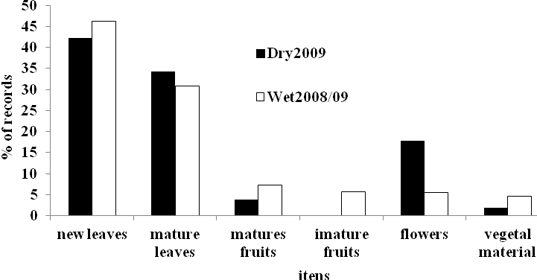
Figure 3. Comparison of the diet of Alouatta caraya between weather seasons 2008 and 2009.

The analysis of the seasonal pattern in the diet, increased consumption of the new leaves in the rainy season is in accordance with the productivity of the period, the same can be said of the consumption of fruits, since this period is characterized by a relative abundance of fruit in the majority of the other study sites (Table 4). The sharp increase in frugivory recorded during the season was entirely due to the appreciation of the fruits of trees genipaps (Genipa americana) and large fig (Ficus enormis), in which the group ‘camping out’ for long periods in this species. The frugivory was marked during the rainy season (12.99%) when compared to dry (3.76%). There were also significant differences between adult group members and immature (Figure 4). Considering that adults spend more of their time resting in shifts (78.79%) than immatures (59.29%), these in turn, devoted more time to all other categories (solitary play were only observed in this age group).

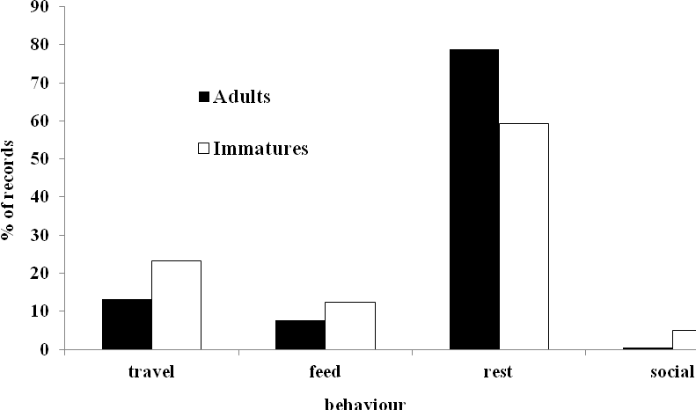
Figure 4. Comparison between adults and immatures in relation to the activity budget, the group of black howler monkeys, Alouatta caraya, according to the records of instantaneous scan sampling.

The differences between age groups were significant at p = 0.05 (Table 5). Although this analysis is relatively simple, it does not indicate that the general budget of activities (Figure 1) may have been influenced significantly by the composition of the study group, which dominates immature members (66.7% of total).

Table 5. Comparison between adults and immatures in relation to the activities budget, of group of black howler monkeys (Alouatta caraya) according to the records of instantaneous scan sampling. Records of scan sampling (% that total) in feed, travel, rest and social interactions at adults and immatures.
Categories | Adults | Immatures | z (p)
Feed | 178 (7.65) | 443 (12.31) | z = 5.41 (p<0.05)
Travel | 304 (13.07) | 833 (23.13) | z = 8.65 (p<0.05)
Rest | 1832 (78.81) | 2135 (59.29) | z = 8.90 (p<0.05)
Social | 11 (0.47) | 190 (5.27) | z = -9.61 (p<0.05)
Total | 2325 (100.00) | 3601 (100.00)

The Figure5, below, presented a comparison betwen the diet of three study groups of A. caraya at different sites in Mato Grosso do Sul state. The groups GroupRiver and GroupLake living in close proximity, less than 3000m. They live in River Basin Aquidauana, GroupRiver in Anastacio town and GroupLake in Aquidauana town. The diet similarity is envident. The folivory is significant, a howler monkey feeding pattern, similar to other A. caraya groups (see Table 4). However, the MaracajuMountain group, that living in Terenos town, presented relevant consume of fruits, a similar pattern that howler monkey groups that living in less disturbed habitats, that Atlantic Forest in Maracaju Sierra (see Odalia-Rímoli et al. 2008).

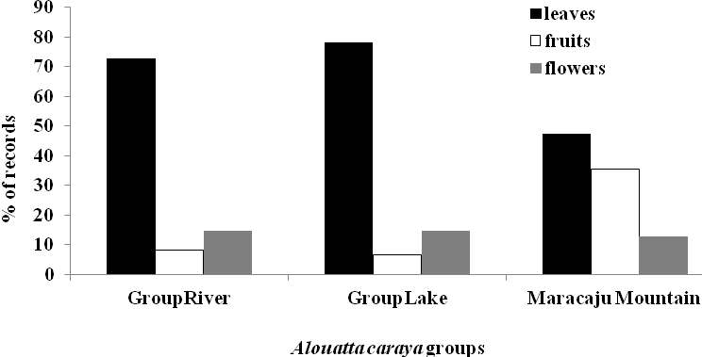
Figure 5. Study groups of black-howler-monkeys, Alouatta caraya. GroupRiver is the actual study group, in left bank of Aquidauana River. GroupLake stay at 2000m for GrupoRiver in Aquidauana town and Maracaju Mounatain stay in “Serra de Maracaju” a large fragment of Atlantic Forest with much more that 8000ha in Terenos town.

DISCUSSION
For the pattern of activities of our group of black howler monkeys, note that the behavioral category was more frequently observed is the rest. In this context, some authors confirm the rest as a useful strategy for sparing energy. For A. caraya at other southern sites (Zunino 1986, Bicca-Marques 1991) and Cerrado-Pantanal sites in the similar region of the study group (Nantes & Rímoli 2008) or other areas of Atlantic Forest (Maracaju Sierra, Odalia-Rímoli et al 2008) confirm this strategy.
The rest tends to be higher in the middle of the day, in periods where temperatures are relatively higher in warmer seasons (spring and summer) and during longer periods where temperatures are low, the colder seasons (winter and autumn). The high rates of rest between the primates of this kind, may be related to a strategy for minimizing energy expenditure, considering the standard folivory in the diet of these animals, i.e., high rates of inactivity seem to be a compensation (trade-off) for feeding behavior based on poor resources (Milton 1980, Neville et al. 1988, Bicca-Marques 2003).
Thus, the behavioral pattern observed among the study group, was very similar to those observed in previous studies with species of the genus (Table 2), in which invariably the predominant periods of inactivity or rest. Although the values for rest, food and travel are similar, respectively, for the genus, it is important to remember the wide range of methodological factors that could influence any direct comparison between studies (see Ferrari & Rylands 1994). In this case, in addition to other possible variables, the relatively large proportion of young members of the group may have had an important influence on overall results. In fact, if only adults were considered (Figure 5), the activities budget would be much more similar to that registered by Bicca-Marques (1991) and Sallenave & Bravo (2003), for example.
The comparative analysis of the sex-aged classes presented here was an attempt since we must consider, among other issues, the marked difference between males and females in this species, as well as the heterogeneity of the immatures (Miranda & Passos 2005, Miranda 2009). However, this analysis clearly indicates that a more systematic approach is required for a comparative analysis of different studies more pronounced, since this would include the standardizing means of sampling, the age, sex, composition of the study groups, and the period of studies, which may considerably influence the recorded values. In Alouatta spp. is often much variation within the variation between groups and species (Table 2). In addition to possible methodological issues, differences may reflect the influence of site (habitats and biomes, for example) at the population level, or even individual factors, making identification almost impossible at interspecific patterns (Odalia-Rímoli et al. 2008).
A similar pattern can be seen in case of food, where folivory predominates in most but not all, species (Table 4). It seems possible that methodological factors may be less important here, and indeed, there seems to be much less intraspecific variation (Odalia-Rímoli et al. 2008). Overall, folivory seems to be more pronounced in populations at higher latitudes, especially those of species howler monkeys that A. guariba and A. caraya, compared with species whose populations are located closer to the equator in the Amazon region, such as A. belzebul and A. seniculus. This may reflect both productivity levels and, especially, the less pronounced seasonality of the equatorial ecosystems (Odalia-Rímoli et al. 2008). The highest consumption and reduced folivory reproductive plant parts such as flowers and partly fruits, recorded for the study group compared to other populations of A. caraya, located in southern Brazil and northern Argentina, would be consistent with this hypothesis, the intraspecific level (Odalia Rímoli et al. 2008). Also reduced by resting periods would be consistent with a diet frugivorous (McNab 1978, 1980), as observed in other atelidae such as spider monkeys Ateles spp. (Chapman 1988, Di Fiore & Campbell 2007) and Brachyteles spp. (Strier 1987), although such behavior patterns for black howler monkeys, A. caraya require that these interpretations are made with some caution when considering the possible influence of methodological issues described above.
The results of this study showed activity patterns and feeding behavior typical of the genus Alouatta, while pointing to possible intra and interspecific differences, encouraging the idea of being made more systematic research on the species. Obviously, there is a clear need for additional studies performed by A. caraya in the Cerrado-Pantanal region, not only to provide new information on the ecological patterns, but also to contribute to the development of strategies for the conservation of species and their habitats.

Acknowledgements: We are grateful to CNPq for the scientific initiation scholarship awarded (PIBIC) for the period 2008-2009 and the Federal University of Mato Grosso do Sul (UFMS), campus Aquidauana, for all the logistical support.

REFERENCES
Agoramoorthy, G. & Lohmann, R. 1999. Population and conservation status of the black-and-gold howler monkeys, Alouatta caraya, along the rio Riachuelo, Argentina. Neotropical Primates, 7: 43-44.
AGUIAR, L.M. 2010. Sistema social de grupos mistos de espécies de bugios (Alouatta caraya e Alouatta clamitans) e potenciais híbridos no alto rio Paraná, sul do Brasil. Tese de Doutorado. Programa de Pós-Graduação em Ciências Biológicas – Zoologia, Setor de Ciências Biológicas da Universidade Federal do Paraná, UFPR, Curitiba.
ALTMANN, J. 1974. Observational study of behavior sampling methods. Behaviour, 49: 227-267.
Altmann, J. 1980. Baboon, Mothers and Infants. Harvard University Press, Cambridge.
BICCA-MARQUES, J.C. 1991. Ecologia e comportamento de um grupo de bugios-pretos Alouatta caraya (Primates, Cebidae) em Alegrete, RS, Brasil. Dissertação de Mestrado, Universidade de Brasília, Departamento de Ecologia, 200p.
Bicca-Marques, J.C. 2003. How do howler monkeys cope with habitat fragmentation? Pp. 283-303. In: Primates in Fragments: Ecology and Conservation (L.K. Marsh, Ed.) Kluwer Academic/Plenum Publishers, New York.
BONVICINO, C.R.; LEMOS, B. & SEÚANEZ, H.C. 2001. Molecular philogenetics of howler Monkeys (Alouatta, Platyrrini): a comparasion with karyotypic data. Chromossoma, 110:241-246.
Bonvicino, C.R. 1989. Ecologia e comportamento de Alouatta belzebul (Primates: Cebidae) na Mata Atlântica. Revista Nordestina de Biologia, 6: 149-179.
Bravo, S.P. & Sallenave, A. 2003. Foraging behavior and activity patterns of Alouatta caraya in the northeastern argentinean flooded forest. International Journal of Primatology, 24: 825- 846.
Chapman, C. 1988. Patterns of foraging and range use by three species of neotropical primates. Primates, 29: 177–194.
Chiarello, A.G. 1993. Home range of the brown howler monkey, Alouatta fusca, in a forest fragment of southeastern Brazil. Folia Primatologica, 60:173-5.
CLUTTON-BROCK, T. H. & HARVEY, P.H. 1977. Species differences in feeding and ranging behavior in Primates. Pp. 557-579. In: Primate Ecology. TH. Clutton - Brock (ed.). New York, Academic Press.
COIMBRA-FILHO, A.F. 1982. Os primatas do Brasil, patrimônio a conservar. Ciência Hoje, 2, 62-69.
Crockett, C.M. & Eisenberg, J.F. 1987. Howlers: variations in group size and demography. Pp. 54–68. In: Primate Societies (B.B. Smuts, D.L. Cheney, R.M. Seyfarth, R.W. Wrangham & T.T. Struhsaker, Eds.) University of Chicago Press, Chicago.
Di Fiore, A. & Campbell, C.J. 2007. The Atelines: variation in ecology, behavior, and social organization. Pp. 155-185. In: Primates in Perspective (C.J. Campbell, A. Fuentes, K.C. MacKinnon, M. Panger & S.K. Bearder, Eds.) Oxford University Press, New York.
Ferrari, S.F. & Rylands, A.B. 1994. Activity budgets and differential visibility in field studies of three marmosets (Callithrix spp.). Folia Primatologica, 63: 78-83.
Gaulin, S.J.C. & Gaulin, C.K. 1982. Behavioral ecology of Alouatta seniculus in Andean cloud forest. International Journal of Primatology, 3: 1-32.
Glander, K.E. 1980. Reproduction and population growth in free-ranging howling monkeys. American Journal of Primatology, 53: 25-36.
Hirsch, A., Dias L.G.; Martins, L.O.; Campos, R.F.; Landau, E.C. & RESENDE, N.A.T. 2002. BDGEOPRIM – Database of geo-referenced localities of Neotropical Primates. Neotropical Primates, 10: 79-84.
Marques, A.A.B. 1996. O bugio ruivo Alouatta fusca clamitans (Cabrera, 1940) (Primates, Cebidae) na Estação Ecológica de Aracuri, RS: variações sazonais de forrageamento. Dissertação de Mestrado, PUC-RS, Porto Alegre.
MARTIN, P. & BATESON, R. 1993. Measuring Behaviour. Cambridge University Press.
MARTINS, C.S. 1997. Uso de habitat pelo bugio, Alouatta fusca clamitans, em um fragmento florestal em lençóis Paulista- SP. Dissertação de Mestrado, Universidade Estadual de Campinas, SP.
MCNAB, B.K. 1978. Energetics of arboreal folivores: physiological problems and ecological consequences of feeding on a ubiquitous food supply. In: The Ecology of Arboreal Folivores. G. G. Montgomery (ed.). Smithsonian Press: Washington.
MCNAB, B.K. 1980. Foods habitats, energetics and the population biology of mammals. American Naturalist, 116: 106-124, 1980.
MENDES, S.L. 1985. Ecologia e Comportamento do barbado (Alouatta fusca) da Estação Biológica de Caratinga (MG). Dissertação de Mestrado. Departamento de Ecologia da Universidade de Brasília, 1985.
Milton, K. 1980. The Foraging Strategy of Howler Monkeys, a Study in Primate Economics. Columbia University Press, New York.
MIRANDA, J.M.D. & PASSOS, F.C. 2005. Composição e dinâmica de Alouatta guariba clamitans Cabrera (Primates, Atelidae) em floresta ombrófila mista no Estado do Paraná, Brasil. Revista Brasileira de Zoologia, 22: 99–106.
MIRANDA, J.M.D. 2009. Comportamentos sociais, relações de dominância e confrontos intergrupais em Alouatta caraya (Humboldt, 1812) na Ilha Mutum, alto rio Paraná, Brasil. Tese de Doutorado. Programa de Pós-Graduação em Ciências Biológicas – Zoologia, Setor de Ciências Biológicas da Universidade Federal do Paraná, UFPR, Curitiba. 104p.
Nantes, R. dos S. & Rímoli, J. 2008. Ecologia e comportamento de bugios-pretos (Alouatta caraya, Primates, Atelidae) em fragmentos florestais em Aquidauana, Mato Grosso do Sul. Relatório Final, PIBIC/UFMS/CNPq.
NEVILLE, M.K.; GLANDER, K.E.; BRAZA, F. & RYLANDS, A.B. 1988. The Howling Monkeys, Genus Alouatta. Pp. 349-453. In: Ecology and Behavior of Neotropical Primate. Vol. 2. Mittermeier, R. A.; Rylands, A. B.; Coimbra-Filho, A. F. ; Fonseca, G. A. B. (editors). Littera Maciel Ltda, Brasil.
ODALIA-RÍMOLI, A.; VALDIVINO, E.M.; RÍMOLI, J. & FERRARI, S.F. 2008. Behavior patterns of a group of black howler monkeys Alouatta caraya (Humboldt, 1812) in a forest fragment in Terenos, Mato Grosso do Sul: a seasonal analysis. Pp. 179-191. In: A Primatologia no Brasil - 9 (S.F. Ferrari & J. Rímoli, Eds.) Aracaju, Sociedade Brasileira de Primatologia.
PINA, A.L.C.B. 1999. Dinâmica socio-ecológica em uma população de guaribas-das-mãos-vermelhas (Alouatta belzebul) na Estação Científica Ferreira Penna, PA. Dissertação de Mestrado, Universidade Federal do Pará, PA.
PINTO, L.P. 2002. Dieta, padrão de atividades e área de vida de Alouatta belzebul discolor (Primates, Atelidae) em Paranaíta, Norte de Mato Grosso. Dissertação de Mestrado, Universidade Estadual de Campinas, São Paulo, 116p.
Queiroz, H.L. 1995. Guaribas e Preguiças. Os mamíferos herbívoros arbóreos de Mamirauá. Sociedade Civil Mamirauá, Brasilia, DF.
Rumiz, D.I. 1990. Alouatta caraya: population density and demography in northern Argentina. American Journal of Primatology, 21: 279-294.
Rumiz, D.I.; Zunino, G.E.; Obregozo, M.L. & Ruiz, J.C. 1986. Alouatta caraya: habitat and resource utilization in northern Argentina. Pp. 175–193. In: Current Perspectives in Primate Social Dynamics (D. M. Taub & F. A. King, Eds.) Van Nostrand Reinhold, New York.
SANTINI, M.E.L. 1985. Alimentação e padrões de atividade de Alouatta caraya (Primates, Cebidae), reintroduzido no Parque Nacional de Brasília – DF. Dissertação de Mestrado, Universidade de Brasília, Brasília, 133p.
Silver, S.C.; Ostro, L.E.T.; Yeager, C.P. & Horwich, R. 1998. Feeding ecology of the black howler monkey (Alouatta pigra) in Northern Belize. American Journal of Primatology, 45: 263-279.
STRIER, K.B. 1987. Activity budgets of woolly spider monkeys, or muriquis (Brachyteles arachnoides). American Journal of Primatology, 13: 385-395.
Williams-Guillén, K. 2003. The behavioral ecology of mantled howling Monkeys (Alouatta palliata) living in a Nicaraguan shade coffee plantation. PhD Thesis, New York University, New York.
ZUNINO, G.E. 1986. Algunos aspectos de la ecología y etología del mono aullador negro (Alouatta caraya) en habitat fragmentado. Doctoral Thesis, Universidad de Buenos Aires, 152p.

