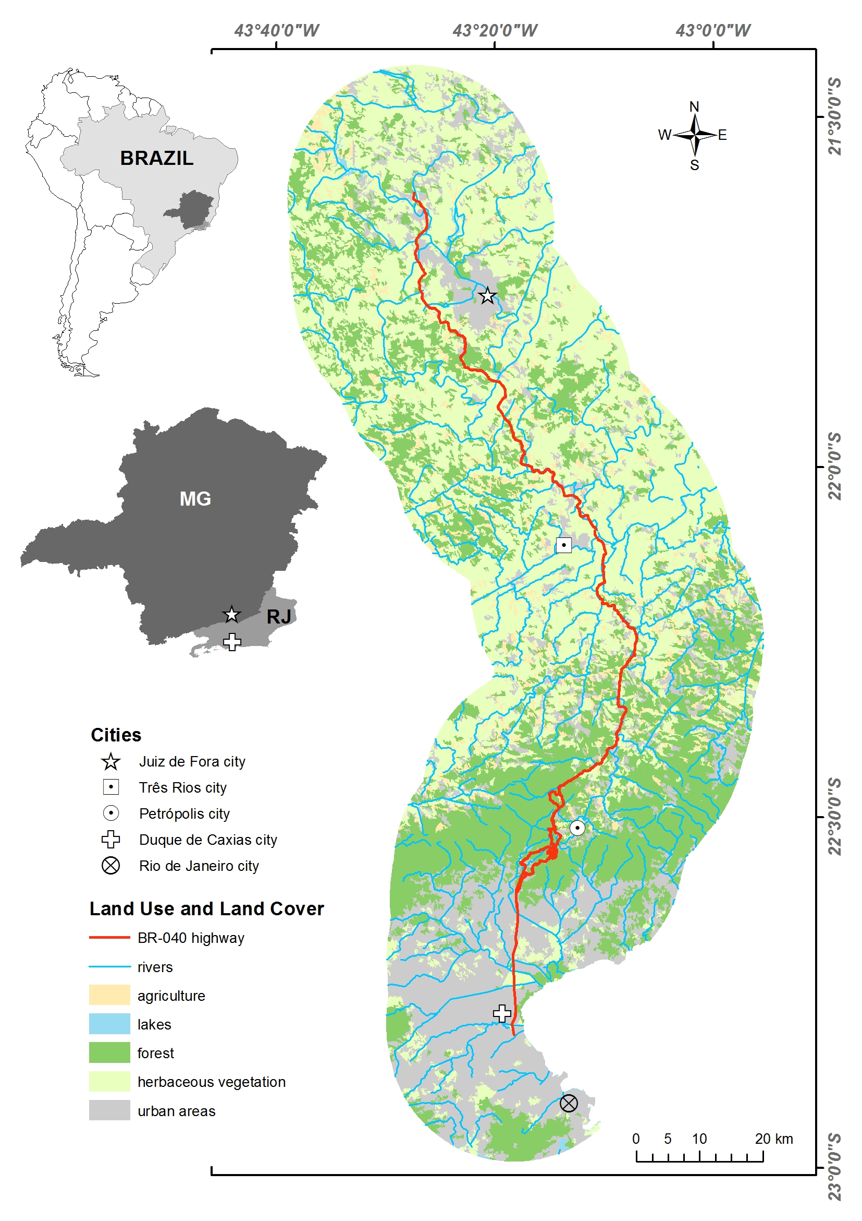
Figure 1. Study area: BR-040 highway from the km 125.1, near Duque de Caxias city in Rio de Janeiro State (RJ) to the km 773.5, near Juiz de Fora city in Minas Gerais State (MG), Southeastern Brazil. Landscape characteristics 20-km around BR-040 highway are shown in detail.

