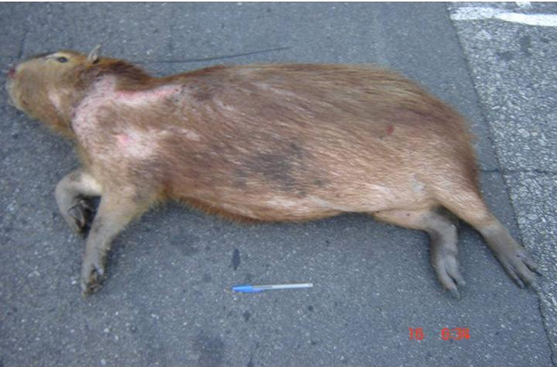

Figure 2. Capybara killed by vehicle collision on BR-040 highway. Photograph taken by Cecilia Bueno.

