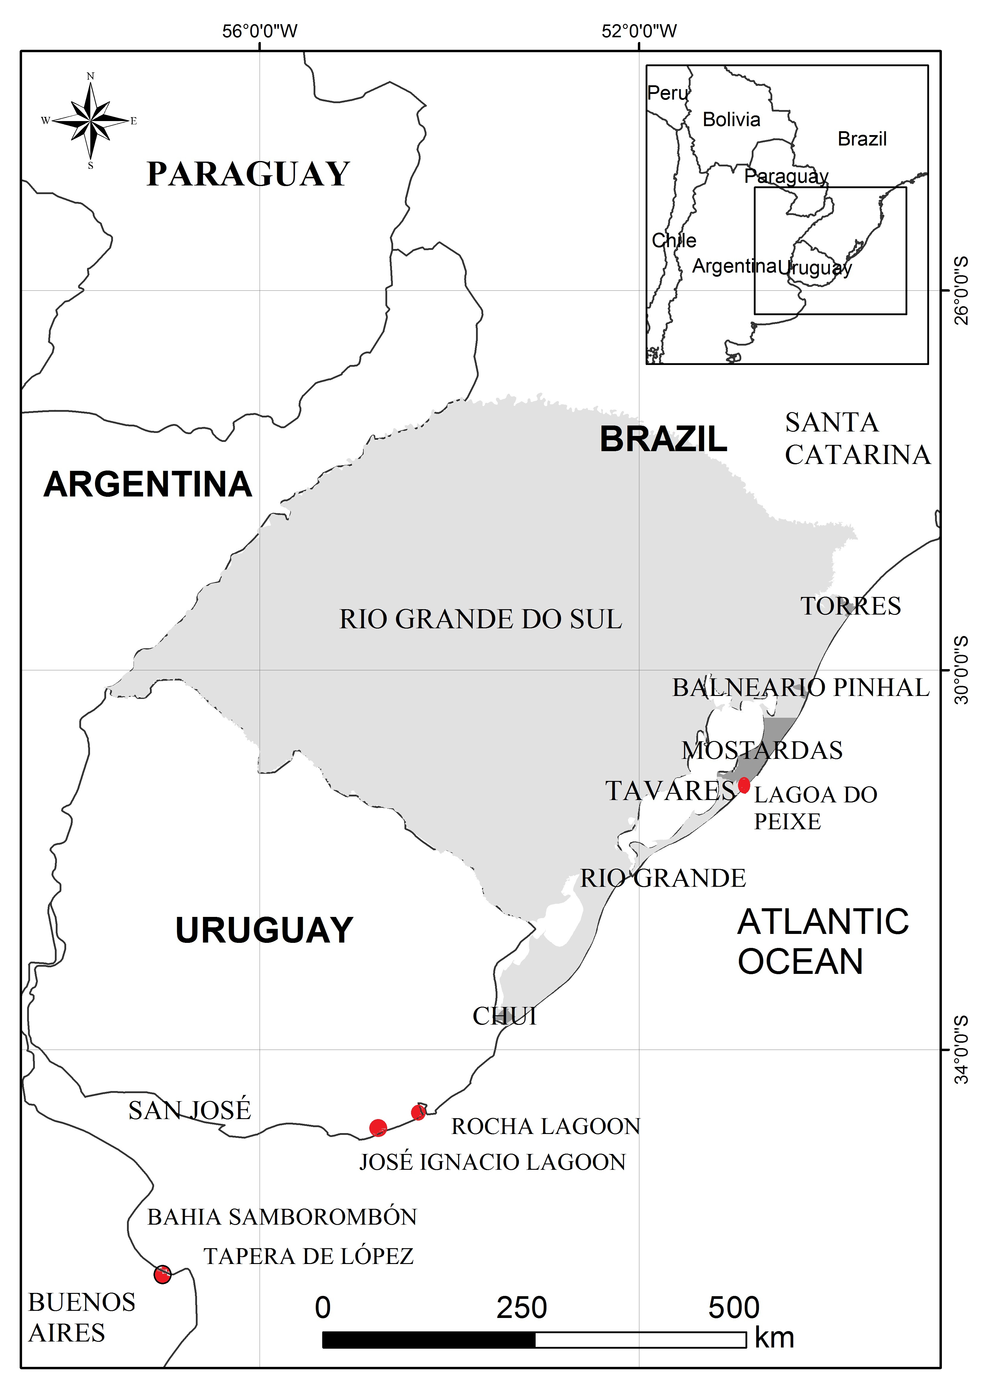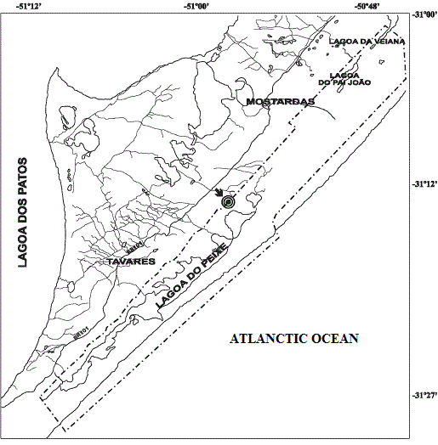
Figure 1. Study area showing the distribution of the Two-banded Plover in the wintering areas. In the right side in detail the Lagoa do Peixe National Park in southern Brazil.

