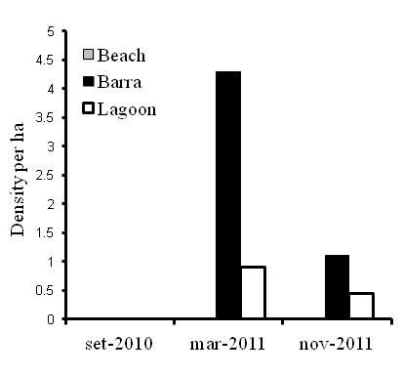
Figure 2. Mean density per hectare of the Two-banded Plover in three different transects in Lagoa do Peixe National Park (PNLP).

