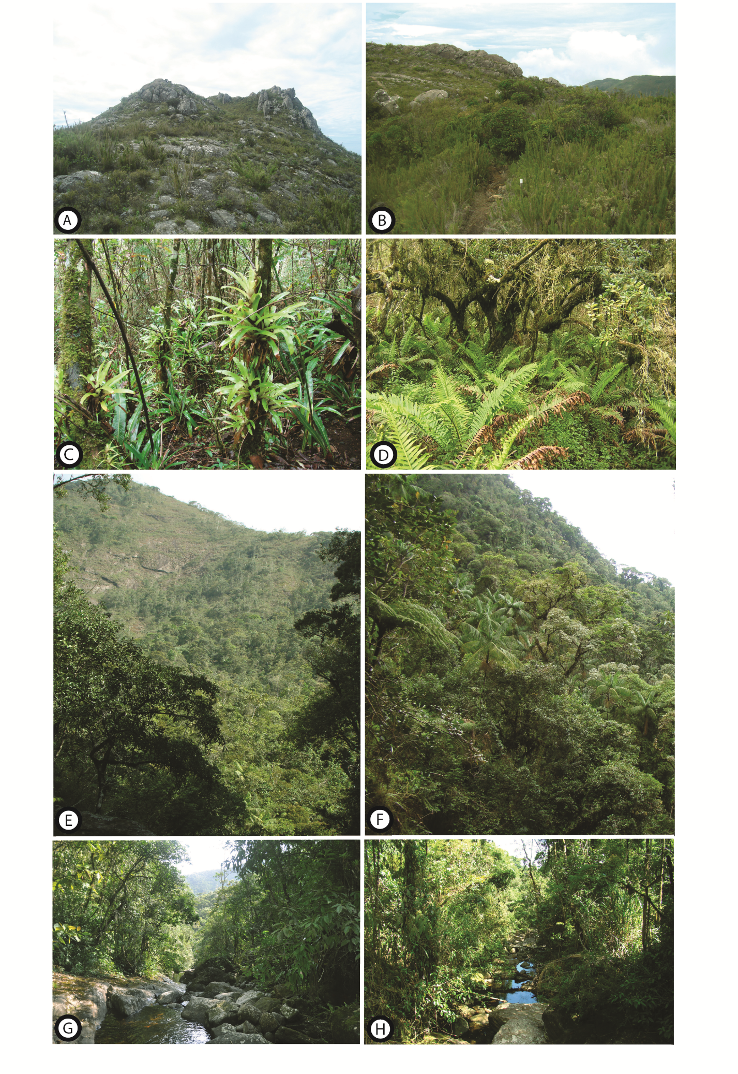
Figure2: Physiognomy in Caparaó National Park. A-B: Hight Altitude Grassland; C-D: Cloud Forest; E-F: Slope Forest; G-H: Riparian Forest.

