DISTRIBUTION EXTENSION OF Tantilla boipiranga (SAWAYA & SAZIMA, 2003) IN THE STATE OF MINAS GERAIS, BRAZIL, AND AN ANALYSIS FOR A DISCREPANT RESULT.

Pedro Henrique Tunes¹, Arthur Toledo Ramos Costa França¹& Rafael Magalhães Mol^{1,2*}
¹Universidade Federal de Minas Gerais, Departamento de Zoologia, Laboratório de Herpetologia, Instituto de Ciências Biológicas, Pampulha, 6627, CEP 31270-901, Belo Horizonte, MG, Brazil. ²Universidade Federal de Minas Gerais, Departamento de Zoologia, Programa de Pós-Graduação em Zoologia, Laboratório de Herpetologia, Instituto de Ciências Biológicas, Pampulha, 6627, CEP 31270-901, Belo Horizonte, MG, Brazil.
E-mails: pedrotunes00@gmail.com, arthurtrcfranca@gmail.com, molrafael2@gmail.com

New records of Tantilla boipiranga (Serpentes, Colubridae) in Minas Gerais, Brazil.

ABSTRACT: Tantilla boipiranga is a rare Vulnerable snake found in the Atlantic Forest and in the Rupestrian grasslands phytophysionomy southeast Brazil. Here, we update the known geographic range of the species to 10 new localities, with one new state occurrence, at 2100 km of the municipality of Almenara the northernmost locality, in the state of Minas Gerais, Brazil, which is a discrepant result for the understanding of the species ecology.
KEYWORDS: Biogeography, Espinhaço, Pará, snake, Squamata
The blackhead snake Tantilla boipiranga (Sawaya & Sazima 2003) (Figure 1) is a Vulnerable Colubrid species (Morato 2010) from the Tantilla melanocephala group, that occurs at high elevations (648>1300m) in the Atlantic Forest biome and in the rupestrian grasslands phytophysionomy southeast Brazil (Sawaya & Sazima 2003, Silveira et al. 2009). The species is characterized by its reddish-orange body colour, by the high number of ventral (147-167) and subcaudal scales (58-70), and by the single and columnar hemipenis morphology (Sawaya & Sazima 2003, Silveira et al. 2009).
FIGURE 1 MUST BE PLACED HERE
Figure 1: Live specimen of Tantilla boipiranga from the municipality of Morro do Pilar, Minas Gerais, Brazil. Photo by Pedro H. Martins
According to Sawaya and Sazima (2003), T. boipiranga was considered endemic to the region of the Parque Nacional da Serra do Cipó, Minas Gerais, Brazil, and afterwards, in a species review had its distribution extended to two new localities: in the municipality of Ouro Preto, and in the municipality of Alvorada de Minas, both in the state of Minas Gerais, Brazil, by Silveira et al. (2009). In this paper, we compiled all data found in the literature related to the old known localities and present 10 new localities for T. boipiranga, extending its known geographic distribution northwards (Figure 2).
The new T. boipiranga records came from different localities through the brazilian territory, mainly in the State of Minas Gerais, Brazil, over the years, on many field surveys for different purposes, and are housed at three herpetological collections: the Coleção de Répteis do Centro de Coleções Taxonômicas do ICB/UFMG (UFMG), the Coleção de Serpentes da Fundação Ezequiel Dias (FUNED-SERP), and in the Coleção de Répteis do Museu de Ciências Naturais da Pontifícia Universidade Católica de Minas Gerais (MCNR). The specimens were morphologically analyzed by the criteria proposed by Sawaya & Sazima (2003), and some of the measurements applied by Silveira et al. (2009) (Table 1) with the use of a measuring ruler (1mm precision) for total length, and a digital caliper (0,02mm precision) for the other measures.
Silveira et al. (2009) demonstrated in their morphological review of some specimens a variation in the number of ventral and subcaudal scales proposing a new species diagnosis of T. boipiranga related to the description of Sawaya & Sazima (2003). In our morphological review, we also found a variation in these morphological traits: 129-175 ventral scales, and 72 subcaudal scales in one male specimen (MCNR 5514) (Table 1), which corroborates with the first hypothesis of Silveira et al. (2009) as the species present distinct metapopulations with varied states of characters in each population, as we can see in the specimens from Brumadinho which borders with the municipality of Ouro Preto. Moreover, we also found an overlap of ventral scales between males and females (Table 1).
Among the new records of T. boipiranga, the only one outside the State of Minas Gerais came from the municipality of Canaã dos Carajás, State of Pará, Brazil. The species record is located at the Serra dos Carajás ferruginous highlands. The area is mainly composed by savanna and grassland vegetations, surrounded by Tropical Rainforest (Arruda et al. 2014). This record extends its distribution 2100 km to the north of the municipality of Almenara, State of Minas Gerais, Brazil, the northernmost known locality, and 2200 km from the species type locality, the Parque Nacional Serra do Cipó. The hypothesis we believe for such a discrepancy in distance from the nearest record is that the specimen in question (FUNED-SERP 1921), may have been collected at another locality nearest to the other records in the state of Minas Gerais, and had its data switched with another animal leading to a false geographic discrepancy between the populations of the species. All the other new records of T. boipiranga came mostly from localities inside the Espinhaço Mountain Range as proposed by Silveira et al. (2009), and the Quadrilátero Ferrífero (Iron Quadrangle Region) (Figure 2).

TABLE 1 MUST BE PLACED

FIGURE 2 MUST BE PLACED HERE
Figure 2: Geographic distribution of previous (spheres - Silveira et al. 2009) and new localities (Triangles) of Tantilla boipiranga. Type Locality is represented by the red star.

The municipalities of Almenara and Berilo are located at the northeast portion in the state of Minas Gerais, Brazil, in the Espinhaço Mountain Range, and are the northernmost localities of the species distribution in the state of Minas Gerais (703 and 471 Km - respectively) from the type locality. Almenara is influenced by the deciduous and semi deciduous physiognomies of the Atlantic Forest domain which was indicated as a priority area for conservation (Fundação Biodiversitas 1998, Andrade 2004, Melo 2005), and Berilo is dominated by the rupestrian grasslands (rocky fields) a physiognomy of the Cerrado biome (Lara & Fernandes 1996).
The municipalities of Santa Luzia, Morro do Pilar, Conceição do Mato Dentro and Serro are located nearest to the Parque Nacional da Serra do Cipó (83 km, 56 km, 71 km and 131 km - respectively) and are influenced by the Cerrado and Atlantic Forest domains, and by the Rio das Velhas basin, one of the most important basins in the state of Minas Gerais (Alves & Pompeu 2005). Furthermore, in the east portion of the state, and influenced by the Rio Doce basin, another important basin in Minas Gerais, are the municipalities of Marliéria, Ipatinga and Caratinga (233 km, 252 km and 338 km - respectively) from the type locality of T. boipiranga. These municipalities are in the Atlantic Forest domain (Lombardi & Gonçalves 2000, Gonçalves & Lombardi 2004). Moreover, the municipality of Brumadinho is located 150 km southern of the type locality, and is considered an ecotone area between the Atlantic Forest and the Cerrado biomes. The municipality is in the Iron Quadrangle Region and area of intensive mineral extraction and agricultural activities (Marent et al. 2011). The region became “famous” due to a tailings dams failure in January of 2019 which killed 249 people with 22 still missing.
We also found another specimen in the municipality of Braúnas (166 km) from the type locality, which is housed at Coleção de Répteis do Centro de Coleções Taxonômicas do ICB/UFMG – UFMG 2715, which we did not include in Table 1 because of the poor conservation condition of the specimen.
As previously mentioned in this paper, T. boipiranga is considered vulnerable due to the severe population fragmentation and lack of information available (Morato 2010). These new records for T. boipiranga covers several new localities outside the Espinhaço Mountain range, but also in the Iron Quadrangle region and in the Vale do Rio Doce area. Moreover, the variation in morphological characters of the populations of T. boipiranga may difficult in the species diagnosis, thus, we believe that more study with the group should be done in order to elucidate the intra and interrelationships among these snakes.

ACKNOWLEDGEMENTS: We thank Paulo Christiano de Anchietta Garcia, Luciana Nascimento Barreto and Giselle Cotta and Flávia Cappuccio de Resende for allowing access to species under their care, and to Pedro H. Martins for kindly provided the image of T. boipiranga.

REFERENCES

Ab'Saber, A. N. 1977. Os domínios morfoclimáticos na América do Sul. Geomorfologia, São Paulo, 52, 1--22.
Alves, C. B. M., & Pompeu, P. S. 2005. Historical changes in the Rio das Velhas Fish Fauna-Brazil. American Fisheries Society Symposium, 45, 587--602.
Andrade, P. M. 2004. Refúgios ecológicos nas matas do Jequitinhonha. Jornal do Biólogo, 37, 6--8.
Arruda, A. J. 2014. Samambaias e licófitas das Serras Ferruginosas da Floresta Nacional de Carajás, Pará, Brasil. 1st ed. [ebook] Belo Horizonte.
Fundação Biodiversitas. 1998. Biodiversidade em Minas Gerais: Um Atlas para sua conservação. Fundação Biodiversitas. Belo Horizonte, Minas Gerais.
Gonçalves, M., & Lombardi, J. A. 2004. Adições ao conhecimento da composição florística de dois remanescentes de Mata Atlântica do sudeste de Minas Gerais, Brasil. Lundiana, 5(1), 3--8.
Lara, A. C. F., & Fernandes, G. W. 1996. The highest diversity of galling insects: Serra do Cipó, Brazil. Biodiversity Letters, 3, 111--114.
Lombardi, J. A., & Gonçalves, M. 2000. Composição florística de dois remanescentes de Mata Atlântica do sudeste de Minas Gerais. Revista Brasileira de Botânica, 23(3), 255--282.
Marent, B. R., Lamounier, W. L., & Gontijo, B. M. 2011. Conflitos ambientais na Serra do Gandarela, Quadrilátero Ferrífero – MG: mineração x preservação. Geografias, 07(1), 99--113.
Melo, F. R. 2005. A Reserva Biológica Federal da Mata Escura e sua importância como Unidade de Conservação para os primatas do Médio Rio Jequitinhonha, Minas Gerais. Neotropical Primates, 13(1), 26--29.
Morato, S. A. A. 2010. Tantilla boipiranga. The IUCN Red List of Threatened Species 2010: eT177582A7461439.
Sawaya, R. J., & Sazima, I. 2003. A new species of Tantilla (Serpente: Colubridae) from Southeastern Brazil. Herpetologica, São Paulo, Brazil, 59(1), 119--126.
Silveira, A. L., Cotta, G. A., Pires, M. R. S. 2009. Distribuição geográfica e variação fenotípica de Tantilla boipiranga Sawaya & Sazima, 2003 (Serpentes: Colubridae). Arquivos do Museu Nacional, Rio de Janeiro, 67(1), 101--93.
Wilson, L. D., & Mata-Silva, V. 2015. A checklist and key to the snakes of the Tantilla clade (Squamata: Colubridae), with comments on taxonomy, distribution, and conservation. Mesoamerican Herpetology, 2(4), 418--498.

Figures and Table

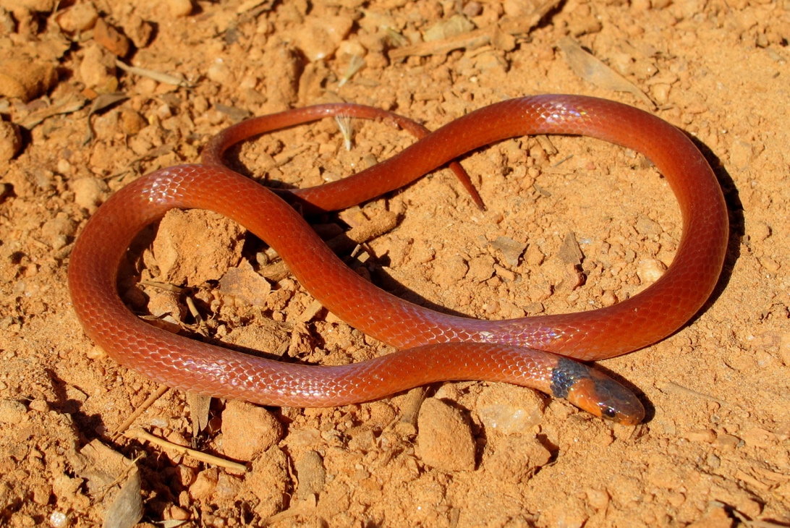
Figure 1: Live specimen of Tantilla boipiranga from the municipality of Morro do Pilar, Minas Gerais, Brazil. Photo by Pedro H. Martins.

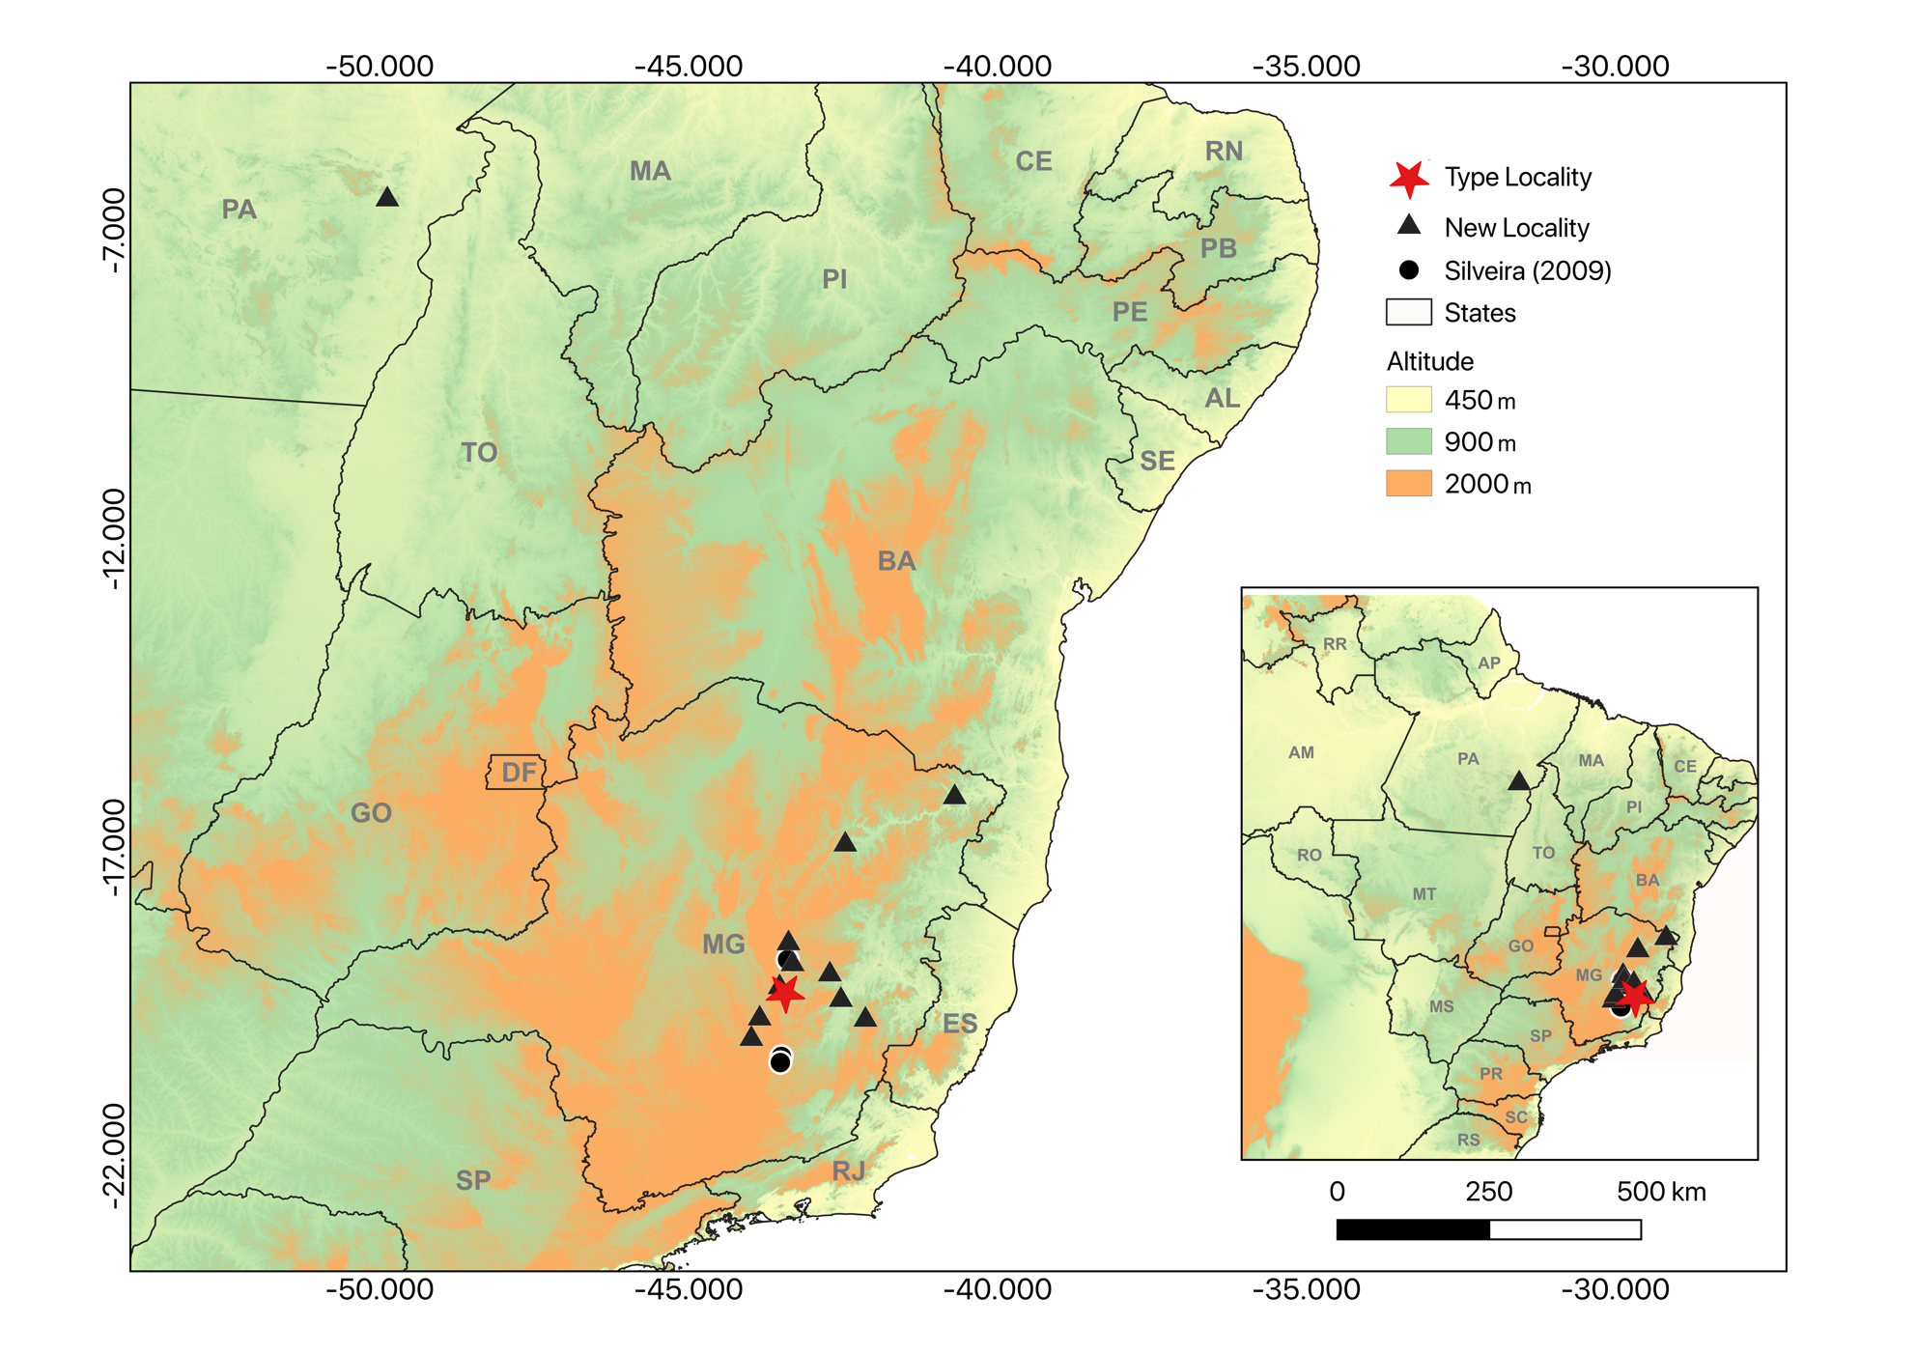
Figure 2: Geographic distribution of previous (spheres - Silveira et al. 2009) and new localities (Triangles) of Tantilla boipiranga. Type Locality is represented by the red star.
Table 1: Morphological review of the analyzed specimens of T. boipiranga in this study. (*) are paratypes (Sawaya & Sazima 2003) of the species housed at UFMG used only for comparison . In dark vertebral line: (a) absent; (p) present, (v) vestigial; and in dark temporal blotch: (a) absent; (c) continuous with dorsal black cephalic staining; (i) isolated; (v) vestigial. The Specimen (MCNR 6274) is incomplete and with a “smashed” head not allowing measurement (n/a).

Specimens | FUNED-SERP 1921 | FUNED-SERP 1953 | FUNED-SERP 2103 | FUNED-SERP 3391 | FUNED-SERP 3405
Gender | F | F | F | F | F
Municipality/State | Canaã dos Carajás - PA | Santa Luzia - MG | Berilo - MG | São Sebastião do Rio Preto - MG | Ipatinga - MG
Coordinates | -49.8783 -6.49694 | -43.8514 -19.7697 | -42.4656 -16.9517 | -43.2976 -19.3372 | -42.5367 -19.4683
Dorsal scales | 15:15:15 | 15:15:15 | 15:15:15 | 15:15:15 | 15:15:15
Gular scales | 3 | 3 | 3 | 3 | 3
Pre-ventral scales | 2 | 2 | 2 | 2 | 2
Vental scales | 167 | 165 | 149 | 149 | 172
Subcaudals | 62 | 60 | 60 | 63 | 35**
Infralabial | 6/6 | 6/6 | 6/6 | 6/6 | 6/6
Supralabial | 7/7 | 7/7 | 7/7 | 7/7 | 7/7
Anterior temporal scales | 1/1 | 1/1 | 1/1 | 1/1 | 1/1
Posterior temporal scales | 1/1 | 1/1 | 1/1 | 1/1 | 1/1
Preocular scales | 1/1 | 1/1 | 1/1 | 1/1 | 1/1
Postocular scales | 2/2 | 2/2 | 2/2 | 2/2 | 2/2
Dark vertebral line | a | a | a | a | a
Dark temporal blotch | v | p | v | a | v
Dark nuchal band extension | 1-5 | 1-5 | 1-4 | 1-5 | 1-4
Total length (cm) | 35 | 49 | 40 | 37 | 59,5
Tail length (cm) | 7,2 | 8,0 | 9,5 | 8,5 | 6
Head length (mm) | 8,01 | 5,0 | 9,32 | 6,1 | 9,30
Head width (mm) | 6,23 | 4,0 | 5,32 | 4,0 | 6,1
Interocular distance (mm) | 2,3 | 3,1 | 3,1 | 3,0 | 4,4
Internasal distance (mm) | 1,61 | 2,0 | 2,0 | 2,0 | 2,2

TABLE 1 CONTINUING…
Table 1: Morphological review of the analyzed specimens of T. boipiranga in this study. (*) are paratypes (Sawaya & Sazima 2003) of the species housed at UFMG used only for comparison . In dark vertebral line: (a) absent; (p) present, (v) vestigial; and in dark temporal blotch: (a) absent; (c) continuous with dorsal black cephalic staining; (i) isolated; (v) vestigial. The Specimen (MCNR 6274) is incomplete and with a “smashed” head not allowing measurement (n/a).

Specimens | MCNR 6274 | MCNR 6316 | UFMG 121 | UFMG 123* | UFMG 124*
Gender | - | F | F | M | M
Municipality/State | Marliéria - MG | Dom Joaquim - MG | Caratinga - MG | Santana do Riacho - MG | Santana do Riacho - MG
Coordinates | -42.6319 -19.6478 | -42.1392 -19.7897 | -42.1392 -19.7897 | -43.6050 -19.3383 | -43.5310 -19.2596
Dorsal scales | 15:15:15 | 15:15:15 | 15:15:15 | 15:15:15 | 15:15:15
Gular scales | 3 | 3 | 4 | 4 | 3
Pre-ventral scales | 2 | 2 | 2 | 2 | 2
Vental scales | 129 | 173 | 153 | 156 | 155
Subcaudals | n/a | 58 | 63 | 64 | 64
Infralabial | 6/6 | 6/6 | 6/6 | 6/6 | 6/6
Supralabial | 7/7 | 7/7 | 7/7 | 7/7 | 7/7
Anterior temporal scales | 1/1 | 1/1 | 1/1 | 1/1 | 1/1
Posterior temporal scales | 1/1 | 1/1 | 1/1 | 1/1 | 1/1
Preocular scales | 2/2 | 1/1 | 1/1 | 1/1 | 2/2
Postocular scales | 2/2 | 2/2 | 2/2 | 2/2 | 2/2
Dark vertebral line | p | a | a | p | v
Dark temporal blotch | v | i | i | n/a | n/a
Dark nuchal band extension | 1-5 | 1-5 | 1-4 | 1-5 | 1-5
Total length (cm) | n/a | 57 | 37,95 | 46,5 | 19,5
Tail length (cm) | n/a | 11,5 | 9,5 | 9,5 | 4,5
Head length (mm) | n/a | 12,77 | 9,31 | 6,83 | 6,47
Head width (mm) | n/a | 7,52 | 5,75 | 3,67 | 4,4
Interocular distance (mm) | n/a | 4,75 | 3,55 | 2,64 | 2,86
Internasal distance (mm) | n/a | 1,73 | 1,48 | 2,28 | 1,59

TABLE 1 CONTINUING…
Table 1: Morphological review of the analyzed specimens of T. boipiranga in this study. (*) are paratypes (Sawaya & Sazima 2003) of the species housed at UFMG used only for comparison . In dark vertebral line: (a) absent; (p) present, (v) vestigial; and in dark temporal blotch: (a) absent; (c) continuous with dorsal black cephalic staining; (i) isolated; (v) vestigial. The Specimen (MCNR 6274) is incomplete and with a “smashed” head not allowing measurement (n/a).

Specimens | UFMG 1175 | UFMG 1936 | UFMG 2539 | UFMG 3230 | UFMG 3251
Gender | F | F | F | F | F
Municipality/State | Congonhas- MG | Almenara - MG | Brumadinho - MG | Morro do Pilar - MG | Brumadinho - MG
Coordinates | -43.8500 -20.4055 | -40.6944 -16.1836 | -44.0018 -20.0520 | -43.5289 -19.2631 | -43.9857 -20.1003
Dorsal scales | 15:15:15 | 15:15:15 | 15:15:15 | 15:15:15 | 15:15:15
Gular scales | 4 | 4 | 3 | 4 | 4
Pre-ventral scales | 2 | 2 | 2 | 2 | 2
Vental scales | 159 | 170 | 162 | 175 | 152
Subcaudals | 68 | 56 | 52 | 52 | 62
Infralabial | 6/6 | 6/6 | 6/6 | 6/6 | 6/6
Supralabial | 7/7 | 7/7 | 7/7 | 7/7 | 7/7
Anterior temporal scales | 1/1 | 1/1 | 1/1 | 1/1 | 1/1
Posterior temporal scales | 1/1 | 1/1 | 1/1 | 1/1 | 1/1
Preocular scales | 1/1 | 1/1 | 2/2 | 1/1 | 1/1
Postocular scales | 2/2 | 2/2 | 2/2 | 2/2 | 2/2
Dark vertebral line | a | p | p | a | a
Dark temporal blotch | n/a | i | c | n/a | i
Dark nuchal band extension | 1 - 5,5 | 1- 4,5 | 1-5 | 1 - 5,5 | 1-4
Total length (cm) | 38 | 41 | 22 | 46,5 | 27
Tail length (cm) | 9,5 | 8,6 | 4,5 | 11,5 | 6,5
Head length (mm) | 9,74 | 11,11 | 3,86 | 11,33 | 6,80
Head width (mm) | 5,74 | 6,96 | 1,39 | 6,92 | 4,11
Interocular distance (mm) | 3,65 | 4,04 | 2,43 | 4,04 | 2,89
Internasal distance (mm) | 2,31 | 2,05 | 1,61 | 2,65 | 1,91

